Bharath Kumar N

PS ID:10843180

Linux 1.2 batch

Day 2 assignment

**Session 1:**

1. **Explain the filesystem hierarchy, mention the importance of /etc**

The filesystem hierarchy in Unix-like operating systems (such as Linux) is organized as a tree structure, starting from the root directory /. Each directory under / has a specific purpose.

Here's a breakdown of the key directories and their roles:

── bin → Essential command binaries (e.g., ls, cp)

── boot → Boot loader files (e.g., kernel)

── dev → Device files (e.g., /dev/sda)

── etc → System configuration files

── home → User home directories

── lib → Essential shared libraries

── media → Mount points for removable media

── mnt → Temporary mount points

── opt → Optional application software packages

── proc → Virtual filesystem for process info

── root → Home directory for the root user

── run → Runtime variable data

── sbin → System binaries (e.g., shutdown, mount)

── srv → Data for services provided by the system

── sys → Virtual filesystem for system info

── tmp → Temporary files

── usr → Secondary hierarchy (user programs, libraries)

── var → Variable data (logs, mail, spool files)

**Importance of /etc**

The /etc directory is **crucial** because it contains **all the system-wide configuration files** and shell scripts used to boot and initialize system settings. Here's why it's important:

**Key Functions of /etc:**

* **System Configuration**: Files like /etc/fstab (mount points), /etc/hostname, /etc/network/interfaces, and /etc/resolv.conf define how the system behaves.
* **Service Management**: Contains configuration for services like cron, ssh, systemd, and more.
* **User Management**: Files like /etc/passwd, /etc/shadow, and /etc/group store user account and group information.
* **Package Configuration**: Many installed applications store their config files here (e.g., /etc/nginx/nginx.conf).

**Why It's Critical:**

* **System Stability**: Misconfigurations in /etc can prevent the system from booting or functioning properly.
* **Security**: Sensitive configurations (like firewall rules or authentication settings) are stored here.
* **Customization**: Admins can tailor system behavior by editing files in /etc.

1. Create a multiple partions and mount these partitions on certain mount points

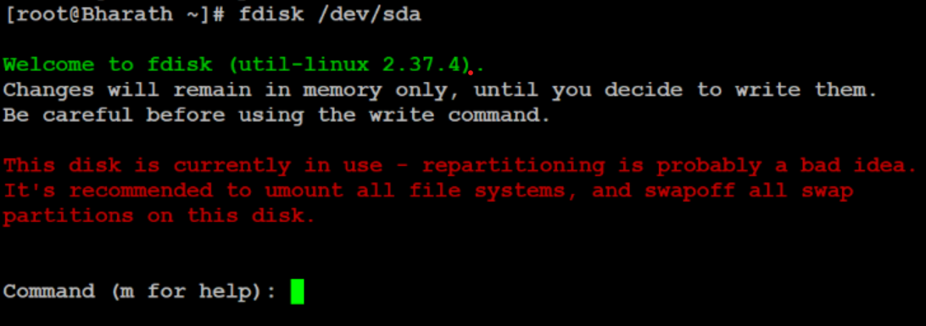

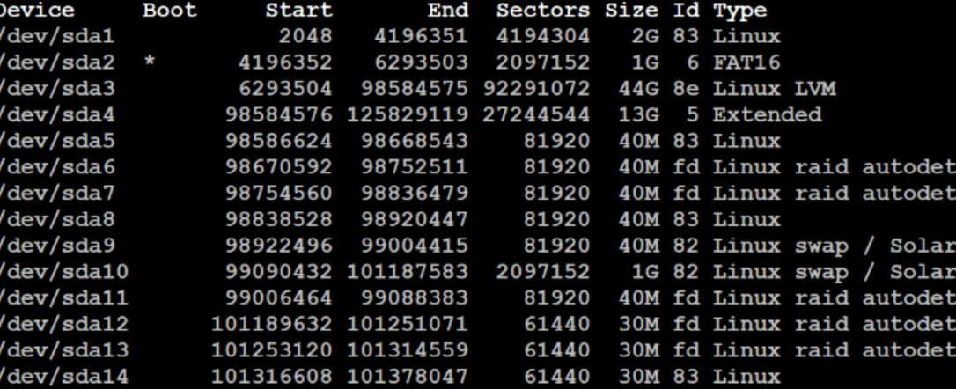

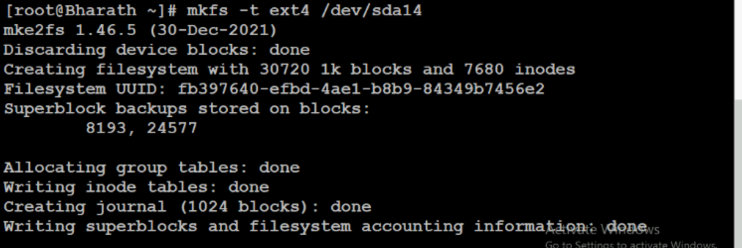

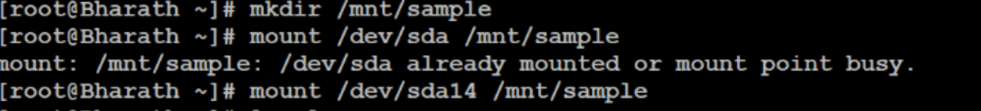

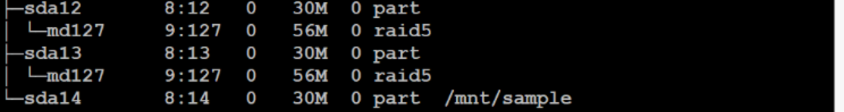

**Session 2:**

* 1. Convert existing ext4 filesystem in to XFS filesystem
  2. Trouble shot the system failure issues due to important of bootable files

**1. Identify the Symptoms**

* Does the system show a “No bootable device” error?
* Is it stuck in a boot loop?
* Are you seeing a BSOD (Blue Screen of Death) or black screen?

**2. Check BIOS/UEFI Settings**

* Restart the system and enter BIOS/UEFI (usually by pressing F2, DEL, or ESC during startup).
* Ensure the **boot order** is correct (e.g., the hard drive or SSD with the OS is listed first).
* Check if the drive is **detected** in BIOS.

**3. Use a Bootable USB/DVD**

* Create a bootable USB using tools like **Rufus** or **Media Creation Tool** (for Windows).
* Boot from the USB and choose **Repair your computer** > **Troubleshoot** > **Startup Repair**.

**4. Run Command-Line Repairs**

From the recovery environment (Windows or Linux), open Command Prompt or Terminal and try:

**For Windows:**

**For Linux (GRUB issues):**

Replace /dev/sdX with your actual boot drive (e.g., /dev/sda).

**5. Check Disk Health**

Use tools like:

* chkdsk /f /r (Windows)
* fsck (Linux)

**6. Restore or Reinstall OS**

If the boot files are beyond repair:

* Restore from a system image backup.
* Reinstall the OS (make sure to back up data if possible).
  1. Give brief overview of different file types supported by Linux OS Explain the concept of file permissions on a Linux system, and describe how incorrect permissions can lead to issues.

Linux treats **everything as a file**, and these files are categorized into several types:

| **File Type** | **Description** | **Example** |
| --- | --- | --- |
| **Regular File (-)** | Contains data, text, or program instructions | /etc/passwd, /home/user/file.txt |
| **Directory (d)** | A folder that contains other files or directories | /home, /var/log |
| **Symbolic Link (l)** | A shortcut or reference to another file | link -> /etc/passwd |
| **Character Device (c)** | Represents devices that transmit data character by character | /dev/tty, /dev/random |
| **Block Device (b)** | Represents devices that transmit data in blocks | /dev/sda, /dev/loop0 |
| **Socket (s)** | Used for inter-process communication | /run/docker.sock |
| **Named Pipe (p)** | Used for communication between processes | /tmp/mypipe |

**How Incorrect Permissions Can Cause Issues**

| **Scenario** | **Problem** |
| --- | --- |
| **❌ Too restrictive** | Users or services can't access or execute necessary files (e.g., a script won't run if it lacks execute permission). |
| **❌ Too permissive** | Security risk — unauthorized users might modify or delete critical files (e.g., 777 permissions on system files). |
| **❌ Wrong ownership** | Even with correct permissions, if the file is owned by the wrong user/group, access may be denied. |
| **❌ Misconfigured directories** | Services like Apache or Nginx may fail to serve files if directory permissions are incorrect. |

* 1. Explain the advantages of LVM over Basic Partition and create PV,VG and LV

LVM (Logical Volume Manager) offers several advantages compared to traditional basic partitioning:

**Flexibility**

* You can resize logical volumes (LVs) dynamically without rebooting.
* Easily extend or shrink volumes as needed.

**Dynamic Storage Management**

* You can add new physical volumes (PVs) to a volume group (VG) and expand storage without affecting existing data.

**Snapshots**

* LVM allows you to take snapshots of volumes for backup or testing purposes.

**Better Disk Utilization**

* Combines multiple physical disks into a single logical volume group, making disk space management more efficient.

**Simplified Management**

* Logical volumes can be named and managed more intuitively than traditional partitions.
  1. Create an LVM partition with 10 GB disk space and set its file system to ext2. Also extend the swap partition to an additional 2 GB.

Session 3:

1. Add 100MB of swap space to your machine using a logical volume
2. Explain different RAID level and their benefits

RAID is a data storage virtualization technology that combines multiple physical drives into one logical unit for **performance**, **redundancy**, or both.

**🔢 Common RAID Levels**

| **RAID Level** | **Description** | **Benefits** | **Drawbacks** |
| --- | --- | --- | --- |
| **RAID 0** | Data is split across drives (striping) | ✅ High performance  ✅ Full storage utilization | ❌ No redundancy  ❌ If one disk fails, all data is lost |
| **RAID 1** | Data is mirrored across two drives | ✅ High redundancy  ✅ Simple recovery | ❌ Storage capacity is halved  ❌ Slightly lower write performance |
| **RAID 5** | Striping with parity across 3+ drives | ✅ Good performance  ✅ Fault tolerance (1 disk) | ❌ Slower write speed due to parity  ❌ Complex rebuild process |
| **RAID 6** | Like RAID 5 but with double parity | ✅ Can tolerate 2 disk failures  ✅ Good for critical data | ❌ Slower writes  ❌ Requires minimum 4 disks |
| **RAID 10 (1+0)** | Mirroring + Striping (RAID 1 + RAID 0) | ✅ High performance  ✅ High redundancy | ❌ Requires 4+ disks  ❌ Expensive (50% storage loss) |

**🛡️ Benefits of RAID**

* **Redundancy**: Protects against data loss due to disk failure.
* **Performance**: Improves read/write speeds (especially RAID 0, 10).
* **Scalability**: Allows combining multiple disks into one logical volume.